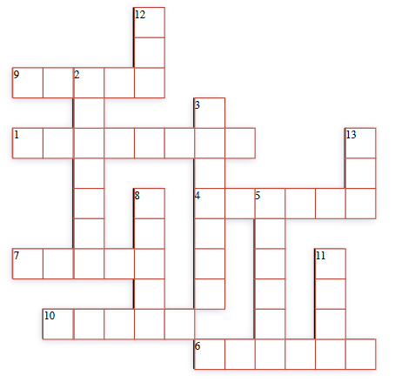

1. You find this animal in Australia and it moves by jumping.

4. It is colourful bird. It can learn to talk.

6. A baby cat.

7. It is black and white, It lives in China.

9. A baby dog.

10. A very big animal in the sea.

2. It cannot fly but it is a good swimmer.

3. This swims in the sea and it likes to jump.

5. It lives under the ground and it likes carrots.

8. It is very slow and it has a shell.

11. You can put a bird in this.

12. Birds do this.

13. This animal flies at night.